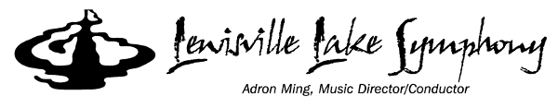

Symphony Intern Program Application Form

Applications accepted from May 23, 2022 – August 31, 2022

In order to provide high value to the participants, membership will be strictly limited. Once capacity has been reached, the Symphony will set up a waiting list for prospective membership during the following season.

Applicants should be available to assist at Friday evening concerts.
Students in high school marching band, drill team, or color guard should only apply for a spring position.
Please use the TAB key to move from field to field.

Applicant’s name: Age: Grade:
(Limited to 8th - 12th grades.)
Address: City/State/Zip:

Phone: Cell:

Email: Parent's Email:

School: School address:

Parents or guardian:

The study of voice or an instrument through private lessons, choir, band, or orchestra is not a requirement for membership. If you do study voice or an instrument, please complete the following.

Instrument: Years of Study:

Teacher/Director: Phone:

Address: Email:

Application requirements:
- a completed application signed by student and parent
- a short essay (Microsoft Word preferred) of 400 words or less on "How does the study of music help in other areas of life?" OR "What makes live music more exciting than recorded music?"
- a letter of recommendation by a choir director, band director, orchestra director, classroom music teacher, private music teacher, or classroom teacher
- photo (Send as a digital file to: intern@lewisvillesymphony.org)
- $30 Intern fee per semester / Instructions for payment of fee will be sent after completing all of the above requirements.
- E-mail the following to: intern@lewisvillesymphony.org.
- Completed and signed application
- Teacher recommendation letter
- Essay
- Digital photo
- Applications accepted from May 23 – August 31, 2022. When all positions have been filled or after the August 31st deadline (whichever comes first), the program will close to new applicants until Spring 2023.

I am available to help at Symphony concerts on Friday nights. If selected as a Symphony Intern, I am willing to assist as needed with House Front activities (handing out programs, click counting, ushering, etc.) prior to concerts. (This may be counted as community service time.) My photo and essay may be used by the Lewisville Lake Symphony as publicity. I understand that Symphony Interns are expected to conduct themselves in a way reflecting the honor of the title and understand that conduct unbecoming will result in removal from the program.

Applicant's Signature: ______________________________ Date ______________________________

Parent's/Guardian's Signature: ________________________________

